The Healthcare Payments Hub: A New Paradigm for Funds and Data Transfers in Healthcare
HIMSS World Bank Task Force
January 2013

Contents
Executive Summary 4
Opportunity 4
Background 4
Current Situation 4
Recommendation 5
Opportunity 6
Market Drivers 6
Key Solution Principles 7
HealthCare PaymentsHub – Concept 7
Background 8
Complex Connectivity 9
Current Situation 10
Overview of Current Claims Processes 10
Emerging Role of NCVHS in Healthcare Payments 12
Operating Rules 13
Straight Through Processing 13
Market Opportunity 14
Paradigm Shift 15
Recommendation 17
A Demonstration Design 17
STP Example 18
Pilot Program 18
Vision Statement for a Pilot Program 18
Examples of Functions within the Healthcare Payments Hub 19
Use Case Summary 19
Approach 20
Milestones 22
Conclusion 22
Appendix 24
Glossary 24
HIMSS World Bank Task Force White Paper Contributors 27
Endnotes 27

Executive Summary

Opportunity
This HIMSS White Paper describes an opportunity for providers, payers, banks, financial networks, and healthcare clearinghouses to establish an interoperable Healthcare Payments Hub that enables Straight Through Processing (STP) of healthcare financial transactions (or, as is the emerging parlance today, “medical banking” transactions). This hub is intended to demonstrate bottom line financial advantage to each of the counterparties involved by creating a functional prototype for Electronic Fund Transfers (EFT)/Electronic Remittance Advice (ERA) management using the STP model.

HIMSS believes that the healthcare payments hub can be demonstrated in a limited fashion at the HIMSS Interoperability Showcase and that this demonstration could spawn an impressive array of innovations that evolve from optimum use of data that is flowing through payment channels. HIMSS encourages the healthcare community to embark upon this path in order to provide strong value and remarkable process efficiency for the stakeholders engaged in the healthcare business process. Toward this end, the paper concludes with a recommendation to form a pilot program. This pilot would comprise existing stakeholders in their various roles while introducing process changes that enhance value to the marketplace through cost savings and improved efficiencies.

Background
Since 2001, HIMSS Medical Banking Project has focused on the ever-increasing links between financial and healthcare transactions. They have sought to work with the financial and healthcare stakeholders to implement a new foundation for streamlining these communications and settlements while assuring this exchange is secure and compliant with all regulatory requirements. This streamlining includes the concept of STP, which financial organizations employ to optimize transactions in such a manner that manual intervention is avoided or completely eliminated.

According to industry experts, banks spend as much as three times more of their annual budgets on information technology compared to the overall healthcare industry. Thus the idea arises that there may be a broad and compelling opportunity to use banking platforms that are already scaled with strong annual investments.

Current Situation
In healthcare today, health plans issue payments via Electronic Fund Transfers (EFTs) and corresponding Remittance Advice transactions or Electronic Remittance Advices (ERAs). These transactions are distinct and typically flow through two completely different paths. EFTs are processed through financial networks and ERAs through healthcare networks. This information is received by the provider and their bank at different times, and they are not inherently easy to match.

In July 2012, HHS published Operating Rules for healthcare payments that include requirements for re-association, timing, and delivery. While these requirements will certainly serve as a catalyst for enhancing healthcare payment needs, the plethora of healthcare transaction delivery mechanisms remains a challenge.

Recommendation
The objective of this white paper is to identify some of the key problem areas that exist and to create a framework for industry action in the form of a "healthcare payments hub” pilot design. The “hub” would address many of the stakeholder challenges in payment processing and enable a much more streamlined approach for cash posting, reconciliation, workflow automation and ultimately, business intelligence.

The industry objectives of the hub, specific goals, operating requirements, and the high level solution architecture and design are all part of the discussion that is outlined in this document. Implementing a pilot is not within scope; however, it is anticipated that any interest generated by this paper can influence the creation of such a program.

Opportunity
This paper describes an opportunity to establish an interoperable “Healthcare Payments Hub” that enables Straight Through Processing (STP) of medical banking transactions. STP is used by companies in the financial world to optimize the speed at which transactions are processed. This is performed by allowing information that has been electronically entered to be transferred from one party to another in the settlement process without having to manually re-enter the same pieces of information repeatedly over the entire sequence of events.

Administrative efficiency is driving the need for a new healthcare financial network. Because this network is central to all stakeholders, each with varying technology and business objectives, there is a need to frame the network’s scope of what is being proposed and why it is needed. Vendors and suppliers will then be able to add value to the payments hub based on their strategic objectives. The successful organic growth of marketplaces like Google, Facebook, and Twitter reveal that a foundational platform with appropriate rules of conduct can generate market creativity and rapid adoption versus over-prescription of market exchange solutions.
This paper includes a recommendation to form a pilot program comprised of existing stakeholders in their various roles that tests some key changes in strategic areas to provide enhanced value to the marketplace through cost savings and improved efficiencies.

Market Drivers
Key market drivers necessitating such a solution include:
- The critical stage that national and global healthcare effectiveness is at
- The importance of global health information exchange and payments
- The value of the healthcare payment exchange is approximately $2.8 trillion*
- ARRA, inclusive of HITECH federal funding for health IT, is a high priority issue with funding that exceeds $20 billion
- Funding requires demonstrating Meaningful Use in a year over year timeframe
- Adoption of health IT is incentivized initially via tax breaks for compliance but then non-compliance includes a penalty structure in future years
- Robust exchange of clinical and payment data affects an entire spectrum of B2B and ultimately consumer entities:
- Providers
- Insurance/Claims
- Employers
- Banks/Financial Institutions
- Federal Entities (HHS, Federal Reserve System, CDC etc.,)
- State Level Administration & Regulation
- Consumers
- Value added Vendors (HIE’s/RHIO’s, Health Vaults, Software Vendors etc.)

*Plunkett Research LTD, 2013

Key Solution Principles
In order to be successful, a network for healthcare payment and remittance data should adhere to several key principles:
- Foster organic adoption based on a compelling ROI
- Be supported at the federal, state, and commercial banking levels
- A security framework that lowers liability barriers and speeds adoption
- Increase payload capacity (versus the current ACH options) or facilitate reconciliation of payments data
- Allow for phased implementation(s)
- Provide independence from a single standard payment message
- Allow counterparties in the network to create their own bi-lateral agreements for service differentiation
- Create financial incentives for participants (Highest value/lowest cost)
- Avoid single large capital concentration or bottleneck project (must rebuild the airplane while in flight!)
- Guarantee delivery and provide non-repudiation
- Create common addressing, billing and delivery standards without prescribing or reading the internal content between the counterparties
- Meet regulatory, audit, and compliance hurdles for HIPAA, SOX, FACTA, etc.
- Implement a pilot project with specific and measurable metrics of success

HealthCare PaymentsHub – Concept
Banks with an interest in forwarding or moving files containing protected health information (PHI) need a payments hub that is configured in a manner that guarantees reduced exposure to PHI. As a result, using open standard security measures such as Virtual Private Networks (VPN), Secure File Transfer Protocol (SFTP) and the
Society for Worldwide Interbank Financial Telecommunication (SWIFT) network should garner support and have wide appeal within the banking community.

Listed below are features of the SWIFT network that make it an ideal platform to pilot the payments hub:
- SWIFT has reportedly never been compromised
- Banks appear to trust it as their own network
- The procedure permits users to prescribe the container, with a guarantee of its secure delivery, without dictating the payload
- It is possible to track workflow and the state of the whole claim and settlement process with status updates available on a web site
- VPN, SFTP, or SWIFT offer connectivity solutions for all entities
- On the banking side, SWIFT connects to or instructs many major settlement systems and exchanges
  - SEPA – Single European Payments Area
  - NACHA (ACH/IACH) – Network of clearing and settlement operators
    - 60% Settled by Federal Reserve banks, 40% settled by the Electronic Payments Network (EPN)
  - FedWire – U.S. Federal Reserve managed wire payment system (RTGS)
  - Continuous Linked Settlement bank (CLS) – FX Netting Engine
  - ClearingHouse (CHIPS) Netting (non-RTGS) system for clearing domestic and international transactions – 47 members, privately held.
  - CHAPS – UK version of FedWire (RTGS)
  - CHATS – Hong Kong version of FedWire (RTGS)
In cases where SWIFT is used, the container size can be up to 250 MB. In other cases the CCD+ (Cash Concentration and Disbursement plus remittance re-association number) reconciliation process can be used if preferred while still delivering workflow status and tracking necessary for all counterparties.

Background
Unfortunately, the lack of a centrally accepted exchange, non-standard message content (with the persistent use of “situational data elements”) and routing or operating rules have not only hampered the financial processes for healthcare (accounts payable and accounts receivable) but have also worked against sound administrative processes resulting in duplicate procedures, higher costs, the inability to automate workflows, longer collection periods, unclear coverage application and lack of accessible information that can be used to support business intelligence.

Healthcare stakeholders clearly need to have interoperable information exchange among all the components that support the financial value chain. This value chain includes commercial banks, healthcare and banking IT vendors and service providers, healthcare providers, and health plans that include self-funded employer groups and others. While the need is well defined there are opposing forces at work between banks and settlement institutions and healthcare payment and provider groups.

On the one hand, providers have to continually revise the detailed data, procedure codes and supporting detail provided to payers in order to meet the requirements of the adjudication process based on the payer contract. The absence of enough data, results in processing delays and/or partial claims settlements. Meanwhile, providers wait for claims to be paid into their receivables bank account with sufficient detail to reconcile the claim in their patient accounting system. On the other hand, the providers' banks may not be interested in handling the supporting detail for the claim (remittance data) and only provide payment data so that they are not exposed to HIPAA and/or HITECH requirements. Consequently, the separation of the detailed EOB (explanation of benefits) from the payment stream can result in hardship for all participants in the financial reconciliation process.

In response to this reality, healthcare stakeholders and other experts conducted a HIMSS G7 session facilitated by the Vanderbilt Center for Better Health in Nashville, Tennessee, in October 2010. This group consisted of leaders from healthcare providers, payers, clearinghouses, employers, the banking sector, and technology providers. Through a creative brainstorming process, the concept of a "healthcare payments hub" architecture was developed as a way to demonstrate a new best practice for healthcare stakeholders to conduct payment and reconciliation processes nationally, and possibly globally.

Complex Connectivity
The typical healthcare provider uses claims clearinghouses to assist in transporting health data transactions and to automate many of the manual processes that support the business of healthcare. In fact, most healthcare organizations use several methods and multiple counterparties for eligibility, claims, remittance, and payment.

Major providers often use dedicated links to their major payer groups, such as Medicare, via dedicated FTP or other secure tunnels. Healthcare providers have made considerable investments in legacy-coded systems, internal hospital processes, and proprietary biller/provider systems and procedures. Often, these systems require additional investment to implement EFT/ERA re-association mechanisms and to support new processes around healthcare STP. The diagram below illustrates many typical large provider and payer network implementations.
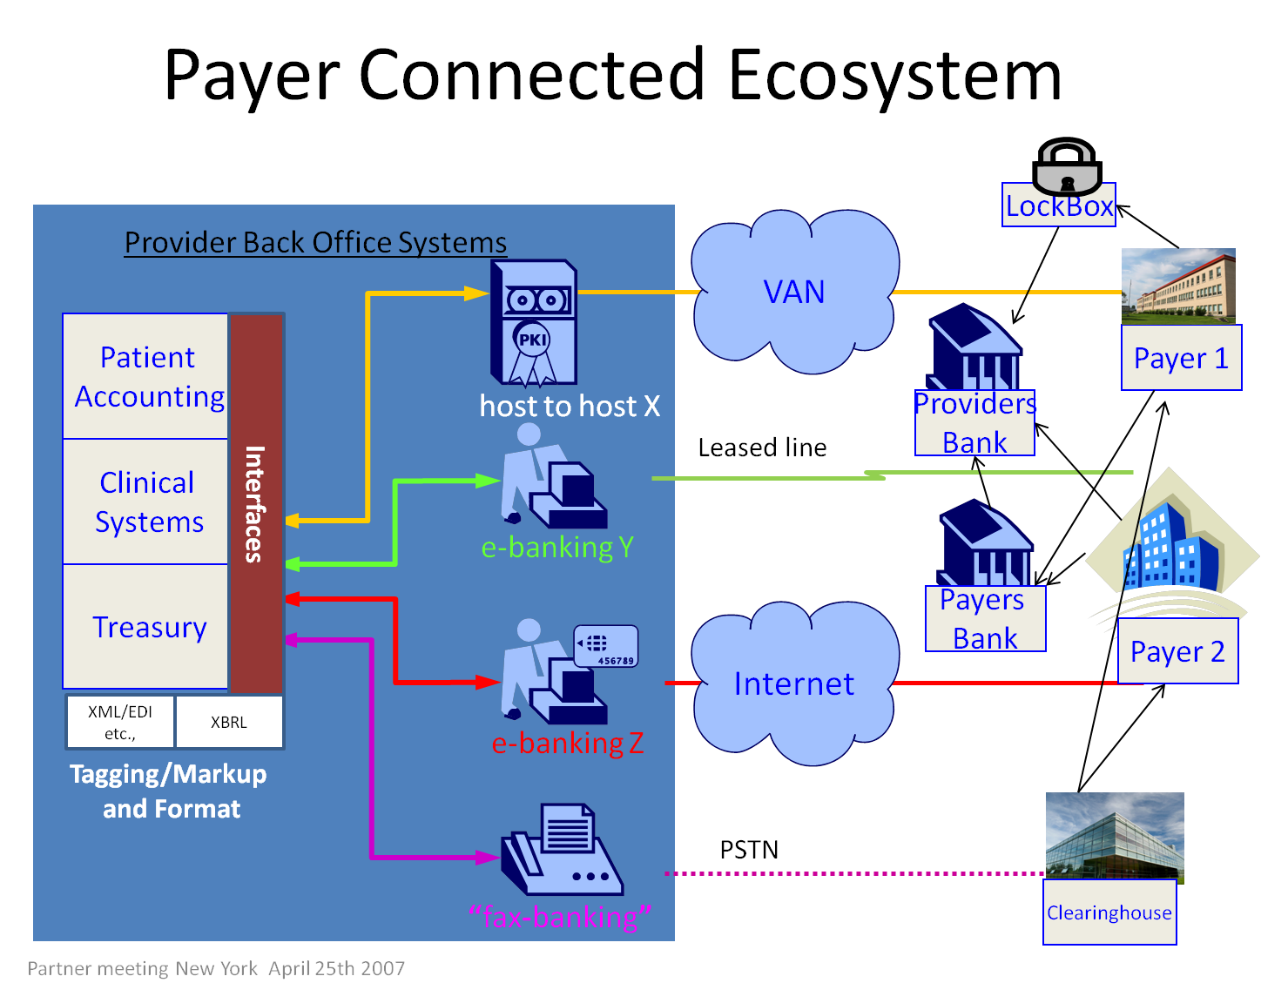
Source: SWIFT Partner Meeting 2007, New York.-Modified counterparties for illustration
EDI connections between the clinical environment and the patient accounting system for most large providers are often manual and disjointed with reliance on batch processing (“data dumps”) and manual data entry and review. There is little true STP in the healthcare environment.

As a result of the federal incentives for electronic records adoption in ARRA, there is growing pressure to drive towards a fully electronic health record standard that can be exchanged as part of continuity of care, with lesser focus on using an EHR for ancillary purposes such as billing and payment. In any case, the number of connected end points and average number of episodes per year that generate claims is large and growing. For example, when we apply the total number of physical locations where back office systems may reside in provider networks and the number of physicians creating data for the patient accounting system, the numbers look daunting (see the table below). For this reason, in order to simplify the overall industry process similar to what has been done in the banking industry, the creation of a payments hub is strongly indicated.

Sampling of End Points that Require Healthcare EDI
Rank | Medical Group | Offices | Physicians
1 | Kaiser Permanante Medical Group | 301 | 7858
2 | Greater Houston Anesthesiology | 11 | 2278
3 | Cleveland Clinic | 104 | 1851
4 | MEDNAX (f.k.a. Pediatrix/Obstetrix Med Grp Nat) | 275 | 1625
5 | Advanced Radiology | 19 | 1349
6 | Mayo Clinic Jacksonville | 37 | 1311
7 | Fairview Physician Associates | 194 | 1295
8 | University Pittsburgh Phys | 156 | 1215
9 | Palo Alto Medical Foundation | 47 | 905
10 | Partners in Care | ? | 850
11 | Henry Ford Medical Group | 60 | 816
12 | Radiology Imaging Associates | 14 | 796
13 | Aurora Medical Group | 88 | 790
14 | Austin Radiological Assoc. | 12 | 754
15 | Marshfield Clinic | 37 | 699
16 | UC Davis Medical Group | 68 | 673
17 | ENH Medical Group | 133 | 664
18 | Harvard Vanguard Medical Associates | 23 | 650
19 | Emory Clinic | 76 | 636
20 | Geisinger Medical Center | 56 | 616
21 | UW Health Clinics | 80 | 612
22 | Ochsner Clinic | 27 | 554
23 | Allina Medical Clinic Coon Rpds | 41 | 552
24 | Carolinas Physician Network | 90 | 539
25 | LSU Healthcare Network Rhu | 55 | 532

Current Situation

Overview of Current Claims Processes
To determine best practices for the future of remittance and settlement, it helps to understand the current state of claims processing. Today, the infrastructure for claims and remittance is highly variable by provider type. Most claim and remittance transactions are communicated electronically. Major providers often establish direct connections for larger entities such as Medicare but do not have direct connections for smaller payers. In those cases, clearinghouses are typically used as a central aggregation hub. Smaller providers may use clearinghouses for all of their claims submissions.

A provider's healthcare information management system captures charges and ultimately creates a claim that is processed in their patient accounting system. Providers are at different stages of readiness for this process, which effectively creates an electronic bill and moves it from the clinical or care environment into a patient accounting or financial system environment. Of importance, the industry has migrated from version 4010 of the ASC health data transactions to version 5010. This will enable the provider to transfer the significant increase in coding as of October 2014, when the ICD-10 coding system will be implemented nationally.

The HIPAA-mandated version 5010, an ASC X12 transaction, provides the standard for the structure of the healthcare transactions. This dictates, for example, where one needs to find the required processing information in the claim (X12 837) or remittance (X12 835). ICD-9 (moving to ICD-10) describes the procedures that were done. In addition these standards include contextual information such as demographics (e.g. patient name, address, insurance provider, etc.). Finally, there are standards for supplementary attachments such as surgical reports and images. Though not implemented broadly, with the population shift to aging baby boomers it is likely these standards will become more commonly used.

Another health data transaction that is integral to the patient visit is eligibility (X12 270/271). Pre-qualification fields in this transaction may be used for full “pre-certification”. Pre-certification goes beyond basic eligibility of coverage and indicates additional criteria such as whether the patient has met their deductible or whether a particular type of procedure is covered. Pre-certification could indicate what condition the patient has and what procedure is going to be performed. Authorization by the payer is granted or the payer may decline the procedure as “not covered” resulting in the need to collect additional payments from the patient or necessitating an appeal to the payer. This information then enables collection of partial to full payment at point of service.

As an example of how the process currently works, a major hospital surveyed for this report uses a partially outsourced model in which a third party assembles batches of claims and remittances and coordinates the deposits to their financial institutions. The hospital is bound to the formats and “standards” of the third party and is required to maintain these at their expense. This includes keeping them up to date any time there is a system change. On the other hand, when a hospital uses a claims clearinghouse, the clearinghouse implements the ongoing changes in data and formats as part of their routine maintenance. In both cases, whether using a partially outsourced model or using a clearinghouse, the hospital is relying on point-to-point electronic interfaces in the form of Internet tunnel VPN, VAN (Value added network), or some other exchange protocol to exchange claims data. There are no standard information highway “on ramps”, “off ramps”, or "fast lanes" on which the data travels.

While we have articulated a very small fraction of the types of health data communications that are routinely among the healthcare stakeholders, it should become evident that the number of connections across the entire healthcare payment landscape is significant. Note that payers and their office locations, providers and their office locations, clearinghouses, lockboxes, associated counterparty banks, and their connected ACH network end-points should also be included.

Looking to the future, it is likely that more claims data, will be required by payers. This will further increase the EDI traffic. Consider the explosion of diagnosis and procedure codes as the industry moves from ICD-9 to ICD-10, a change that will more precisely codify the patient episode. The need for a more robust data transfer system begs the question of whether the right infrastructure is in place to handle the increasing intensity of data exchange.

For banks to play a more meaningful role in healthcare information management and payments, they will require a highly secure transport network beyond the Internet for limiting exposure under HIPAA. New requirements would include items such as:
- release rules
- validation of required elements in the file
- security and network exchange protocols
- a digital signature that consistently satisfies HIPAA requirements without relying on every counter-parties’ individual security plan and implementation

As claims become more detailed and as technology converges to optimize payment and remittance management among payers, providers, and banking organizations, there will be increasing pressure for an STP solution. The solution will need to be highly secure, as more records, and thus more data, is communicated.

Emerging Role of NCVHS in Healthcare Payments
A recommendation by the NCVHS (The National Committee on Vital and Health Statistics), acting as a statutory advisor to the Department of Health and Human Services (HHS), suggested that the EFT and the ERA do not need to be submitted together; in fact, NCVHS determined that the payment and remittance information should be submitted separately using the CCD+ NACHA payment transaction.

CCD stands for Corporate Cash Disbursement, and the “+” represents a part of the transaction that can house a trace number that links the EFT and ERA back together. This process is called “re-association” and is performed by the recipient of funds, the recipient’s bank, or the HIT service provider. In this process, the funds (EFT) may travel separately from the data (ERA) but are then re-associated at the destination. While appearing to simplify the reconciliation process, it is not clear if this practice facilitates STP, which assumes that all of the remittance data is submitted with a payment.

One option that has been considered is to envelope both the EFT and the ERA within a CTX (Corporate Trade Exchange) transaction (a NACHA format) and deliver them together through the ACH network. However, healthcare plans and healthcare providers have indicated concern around doing this due to a lack of trust that the ACH clearinghouse networks fully comply with HIPAA. During testimony at NCVHS hearings on this topic, the Veterans Healthcare Administration, responsible for a large provider network of hospitals, clinics and other healthcare facilities, made discrete recommendations to ban the CTX and to require stakeholder-wide use of the CCD+.

Operating Rules
In July 2012, HHS published Operating Rules that include re-association, timing, and delivery requirements for healthcare payments. These rules require that by January 1 of 2014 all health plans must support EFT, with various requirements including:
- Requires EFTs to be delivered in CCD+ format, which means they must include linkage to their corresponding Electronic Remittance Advice (835)
- Requires that 835s are sent by the health plan no longer than three days before or after issuing the EFT.
With these new requirements, the potential use of the CCD+ will increase; however, the benefits that come from STP would largely go unrealized. While re-association may become the standard industry practice – linking the EFT and ERA using the CCD+ format – there may still be an opportunity to realize a more robust healthcare payment experience that provides compelling ROI for the stakeholders using a true STP approach.

Straight Through Processing
The advent of STP among business enterprises has yielded strong business value. According to Wikipedia, “Straight-through processing (STP) enables the entire trade process for payment transactions to be conducted electronically without the need for re-keying or manual intervention, subject to legal and regulatory restrictions.”

Clearly, the business of healthcare is in need of streamlined systems and processes in several key areas. The adaptation of STP practices could provide strong business value for the healthcare provider. In a growing number of cases, healthcare providers are already piecing together the technology components that can advance this area through point applications that process electronic remittances into the patient accounting platforms. Dollars that are received, and their associated remittances, are being automatically reconciled with bank accounts, are posted, and are kicking off a wave of downstream processes that traditionally required manual intervention.

Moreover, banks and financial institutions are playing an increasing role in the healthcare field by offering new data processing services that address healthcare STP and provide other value added services for the stakeholders that leverage their “first in line” position for receiving and processing electronic remittances when those remittances are sent to the provider with the healthcare payment. These services are referred to as “medical banking” and have generated new thinking around best practices for revenue cycle management according to a major hospital network.

Yet in many circumstances, the processing of claims payment and remittance advice requires significant manual intervention at various points between the provider and the payers, including clearinghouses, IT vendors, and banks. The current processes and supporting infrastructure generally do not allow for even simple end-to-end reconciliation. Receivables outstanding may be adversely impacted as payers adjudicate claims, engage in Q&A with providers on coverage specifics and ultimately settle payments to the provider’s bank.

Market Opportunity
In defining the requirements for a healthcare payments hub architecture, it is necessary to identify all of the impacted stakeholders in the processing environment. The diagram below outlines the full landscape.
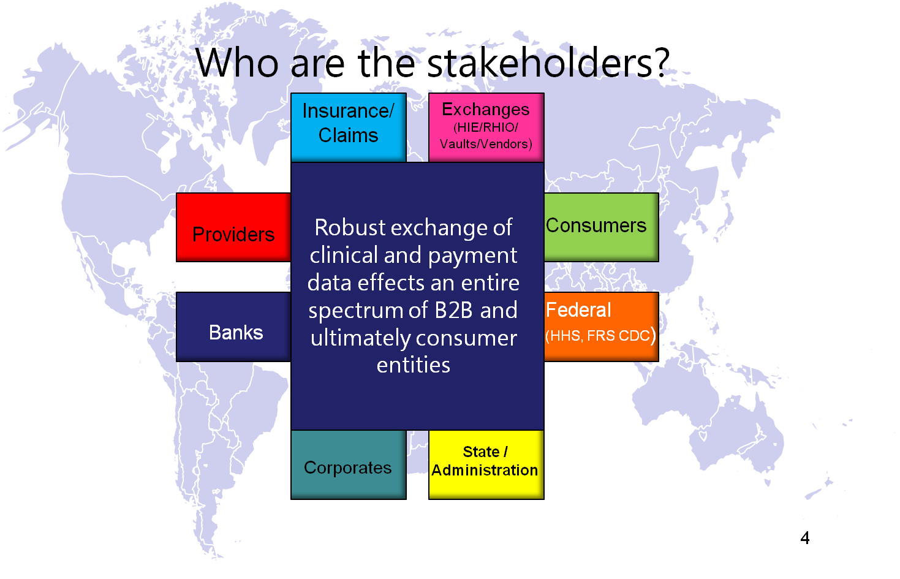
Within this ecosystem, the market transaction size is somewhat staggering:
- Claims market size: 6 billion+ (claims processed to third party payers, not patient pay)
- Third party payer remittance market size: 12 billion (conservative estimate based on receiving a small number of partial payments for each claim)

The estimated remittance breakdown is:
- Commercial: 5 billion (includes all commercial payers, BC/BS)
- Government: 7 billion (includes Medicare, Medicaid, Champus and other government plans)
- Self-pay remittances: 18 billion (based on an average of 3 additional payments for each claim)

The estimated number of EDI connection points for just hospitals, payers and physicians is:
- Hospitals: 6,000
- Payers: 2,000 (note that the number of health plans is different; Aetna alone offers hundreds of health plans)
- Active physicians: 750,000

Collectively, this data exemplifies the market opportunity and the scope of impact for a new healthcare payments hub. This type of innovation could provide an efficient payment and remittance channel between the stakeholders that dramatically increases administrative efficiency in healthcare.

Paradigm Shift
A Healthcare Payments Hub could instigate a “sea change” in the healthcare payments area. This paradigm shift will tend to be driven by six major factors:

Demand –Medical banking involves the identification of increasing dependencies between the healthcare and banking industries that could be leveraged to drive systemic efficiency in the infrastructure of our healthcare systems. This intersection transacts a healthcare marketplace valued at $2.5 trillion (in 2009), yet the component parts are comprised of disconnected point solutions, proprietary technologies, and a heavy reliance on manual processing. Collectively, these practices lag far behind other industries. Through the applied use of a payments and remittance platform, it is possible to enjoy high value data exchanges that offer “near real time” transaction management. As more groups find the value, the demand for efficiency will evolve the platform.

Leverage Existing Connections – A payments hub efficiently consolidates multiple counterparty connections, economizes on-boarding to new connections, and reduces maintenance costs. This type of system would allow much more rapid adding and changing of counterparty relationships between payers, providers, clearinghouses, and their processing financial institutions. The more members that join, the more likelihood their desired counterparty is already connected resulting in minimum connection cost for members. The benefit of standardized connections would save considerable time and effort and result in optimum management of this redundant cost center.

Neutrality – Banks are the end-point for virtually all payment settlements. As a result, the banking community is noted for creating a neutral, trusted financial platform for data exchange.

Value Added Services – Since the payments hub would be a "traffic cop" of sorts between healthcare providers, payers, clearinghouses, and their banks, it could leverage its position to offer value added services. This would help clearinghouses build their business connection model and provide web-based reporting for transaction research, archiving, and other services.

Security – If any industry has the need for robust security, payload capacity, guaranteed message delivery, and non-repudiation that mimics the trusted global bank backbone, it’s the healthcare industry. Concerns over medical record exchange in the form of payments with remittance detail, lack of standard Personal Health Records (PHRs), and the inherent risk of disclosing personal medical details across the Internet, have plagued any interoperable cross-business exchange. Any solution that reaches meaningful adoption levels will have to address the security and risk of information concerns of all the counterparties. Secure FTP, Digital Certificates and other methods can be used to secure provider and other connections to the hub.

Within the context of financial settlements, and the types of privacy and security safeguards that are routinely used, few environments can surpass the US banking system. External to the US, when connecting to banks and major financial exchanges, SWIFT security is well respected. However, regardless of the platform, a comprehensive HIPAA/HITECH assessment is required. While SWIFT has reportedly never lost a message (and none have ever been intercepted by a non-member third party), it would need to, as with any financial platform, provide evidence that its use is satisfactory to the healthcare stakeholders. It will need to demonstrate that it uses, at a minimum, the HIPAA-specified standards around security and data delivery. This will help to speed adoption of prospective STP business practices.

Financial institutions will naturally have different risk tolerances and therefore differing business offerings to healthcare. Their risk tolerance will drive whether they want to be involved in strict financial settlement or in other value added services to healthcare that may deem them “Business Associates” and “Covered Entities” that are subject to the HIPAA and HITECH regulations.

Standards without Standards – The global banking industry has spent years laying the groundwork for global standard messages. Connected counterparties can process global standard payment, detailed bank statements, and many other financial messages on a
trusted and secure information highway. The evolving ISO standards for XML tagging (and XBRL) are useful in taking the documents that describe relationships between business counterparties and allowing technology to apply them dynamically in a settlement of claim use case.

In healthcare, evolving standards and complexity is a larger problem. Consider that within the area of electronic health records, there are a number of emerging standards such as CCR, CCD, and ISO 13606. Furthermore payer-specific variations remain within the 837 and 835standards. Given this reality, it may be that there are trading partner nuances that need to be “baked” into the transactional ecosystem (i.e., for example, note the large amount of companion guides in the claim process). While having a standard is clearly in the best interest of the healthcare stakeholders, there are some exchanges of information that may benefit from transfers of payments and data without a standard message type, in a format that the correspondents agree to, while still offering the security, audit, guaranteed delivery, and banking system integration benefits.

In proposing a payments hub that offers a standard and reusable transport, robust security, and routing and delivery, we envision the first ever platform for universal healthcare payments exchange. This effort would be analogous to defining an international shipping and payment process. So for the payments hub, we would suggest not prescribing everything inside the “shipping container” but rather leave that to competitive market forces and bi-lateral agreements between trading partners, and/or legislative fiat (as in the US with version 5010 of the health data transactions)

The next section provides a pilot design. This pilot design focus would instead create the equivalent of standard tags and container sizes for loading export commodities onto ships through their ports of call. The container shape, size, construction, loading and unloading hooks, and secure transport regulations around them would be standardized while the content within them could still vary. In this way, the trading partners (e.g., provider and payer) could use their own business relationship agreements and settlement networks to drive the format requirements they require.

Recommendation
A recommendation based on the current opportunity is provided in this section, followed by the description of a pilot program that can demonstrate a stakeholder-wide value proposition.

A Demonstration Design
Since the main efficiency problems in the healthcare payments value chain have yet to be solved, there may be a place for a “payments hub” that can support both separated EFT/ERA transactions as well as an alternate larger and secure payload package that contains all of the information in one bundle. In this paper, we examine the use of the SWIFT organization for this purpose.

SWIFT is an international financial messaging platform that is used for wiring funds. In recent years, however, the organization has expanded its scope into other types of transactions. This includes the “FileAct” transaction which allows secure and reliable transfer of files and is typically used to exchange batches of structured financial messages and large reports. FileAct supports tailored solutions for market infrastructure communities, closed user groups and financial institutions. FileAct is particularly suitable for bulk payments, securities value-added information and reporting, and for other purposes, such as central-bank reporting and intra-institution reporting.

In the SWIFT scenario, the healthcare payment transaction would essentially envelop the CCD+ (to comply with the new federal operating rule requirements) but then additionally offer the required space for the related remittance data in the same package – thus supporting a straight-through process. A demonstration project using FileAct could showcase a financial infrastructure that reduces costs across the healthcare ecosystem.

One large healthcare system suggests that an STP-enabled approach could serve their national footprint extremely well and listed the following design features:
- Connectivity with the majority of existing banks, clearinghouses, and vendor partners
- Pre-built services that include a number of workflow functions, such as payer-specific edits, eligibility verification, EDI transactions reporting and analytics, payment and remittance reconciliation, standard remittance and denial code management
- HIPAA security requirements including encrypting and separating enterprise information in storage and transit, ensuring services are not mingled with other customers, etc.
- The ability to benefit from financial incentives such as volume discounts unavailable through a single vendor solution

STP Example
For an example of STP in action, consider the following:
- Joe Corrales is treated by a provider; his claim is processed through ABC clearinghouse which sends an edited version (X12 837) to ABC Insurance Corp.
- ABC Insurance Corp adjudicates the claim and processes a payment that is loaded into a batch payment file. The file is submitted to ABC Vendor that prepares it into a CCD+ transaction (EFT plus ERA re-association information) and an EDI835 (ERA with re-association information). They then send these to “First Medical Bank” for execution.
- First Medical Bank sends the CCD+ and the 835 over SWIFT (banking network) for secure transport and guaranteed delivery
- SWIFT processes the CCD+ through the ACH Network all the way to the RDFI (provider’s bank) and sends the 835 directly to the provider.
- Provider picks up the 835 and reconciles with their bank account (which may also be reported via SWIFT); and then processes the ERA into their patient accounting system.

Pilot Program
This section outlines the specific recommendation for the creation of a healthcare payments hub pilot.

Vision Statement for a Pilot Program
A successful pilot program requires a common vision among all the healthcare stakeholders. The payments hub could support multiple useful functions. The following vision statement could be used to appropriately scope a pilot program.

We envision a new healthcare network solution beginning in pilot and growing into a common standard where stakeholders and their service providers enjoy robust and standardized B2B remittance and payment exchange via a hub and spoke architecture. As a result, healthcare and related service organizations and exchanges will become fully in control of their global transactions, records management, payments, and receivables pipeline.
The benefits of a payments hub would:
- Improve overall revenue cycle management across the industry
- Improve cash flows for all counterparties
- Decrease the cost and complexity of transaction processing
- Promote unprecedented interoperability of banking and financial systems
- Increase healthcare STP and offer near real-time data exchange between the stakeholders
- Increase acceptance rates of electronic transactions
- Offer an innovation platform for vendors and financial institutions to expand services
- Increase visibility into healthcare payment transactions

Examples of Functions within the Healthcare Payments Hub
- Provide secured connections to payers, providers and clearinghouses via SFTP, VPN, Digital Certificate etc., while connecting to banks via SWIFT
- Offer server-side web-based technology setup so no client installation required
- Support CCD+ for transaction trace identification and send individually and/or inside of the FileAct-based bulk remittance via SWIFT

This type of platform could be implemented as a fully functioning demonstration within the HIMSS Interoperability Showcase. In addition, the demonstration could include workflow status and associated dashboards for tracking transactions via a web browser, with export to CSV or Excel formats that enable STP integration with patient accounting systems.

Use Case Summary
Use Case: Healthcare Payments Hub and Value-Added Vendors
Today’s Process | Actor | What to potentially demonstrate around this process
Value-Added Vendor: Claim sent to payer by healthcare provider | Healthcare claims clearinghouse | Eligibility process, authorization process, new edit methodologies, other.
Value-Added Vendor: Payer adjudicates | Payer and/or payer’s vendor | Advanced payer platform that expedites adjudication process; could demonstrate a real time process for some claims that are eligible for processing in this manner
HUB:Payment batch file released | Payer’s third party and/or bank that provides AP services | Show how the file is “spliced” and payments are executed via electronic process or paper process or other. Of particular note: what happens to the payment and the associated remittance
HUB:Payment is processed by financial institutions | For EFT, NACHA and/or SWIFT could play a role here | Show the movement of EFT/ERA linked together, or, show their movement separate but with the bank having the ability to link (or a third party)
HUB:Payment is reconciled to the provider’s bank account | Commercial Bank: RDFI or Lockbox, Lockbox Vendor, Third party application service providers | Show the process of reconciliation – a major sore point for providers
Value Added Vendor: Payment is posted to patient accounting platform – comprehensive posting: cash posted, contractuals, reject notes, financial class updates | HIS, specialized application vendor (claims clearinghouses with this capability, etc.) | Show the benefit of moving all the paper EOBs through a digitized process for remittance management
Value-Added Vendor:Denial management | Denial management vendors | Show automated denial management routines versus paper-based
Value-Added Vendor:Contract Management | Contract management vendors | (same as above except for contract management)
Value-Added Vendor:  Business Intelligence Analytics for enterprise or practice management | Analytic IT vendors that use the remittance data to assist in enterprise decisioning | Show the relative value of enterprise decisioning using automated processes versus manual/paper processes (including mitigation of paper-based errors that propagate through revenue cycle and the making of bad decisions).

Approach
The diagram shows a sample approach for architecting a hub that could be used in the healthcare industry.
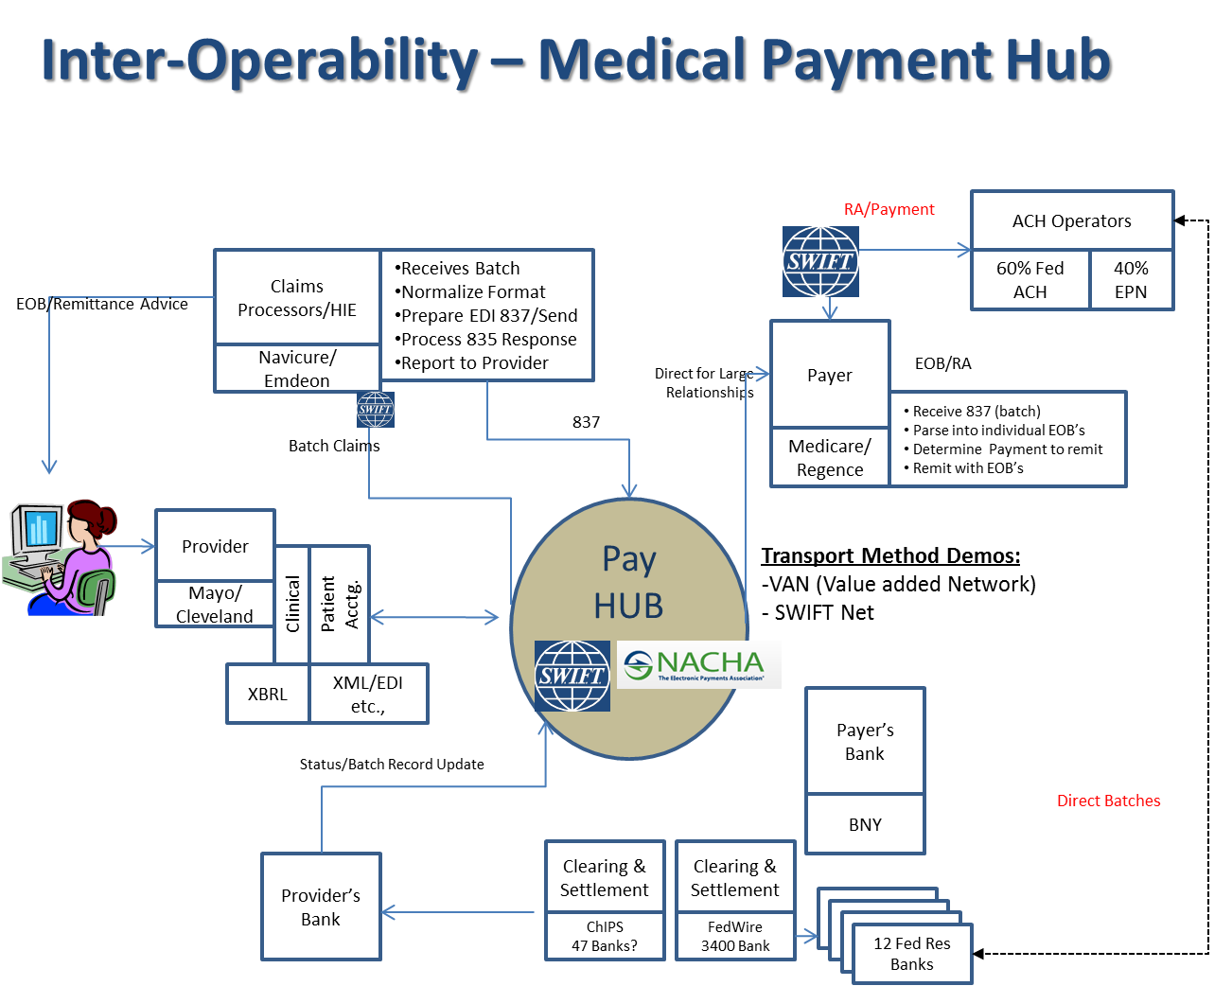

The components of a successful approach could be:
- Define criteria for success of pilot
- Define and document key requirements
- Define business case showing tangible and intangible costs and benefits for counterparties
- Define use cases for the pilot encompassing the top potential uses of the network
- Recruit pilot participant
- Secure resources
  - Funding
  - Knowledge/Expertise
  - Infrastructure
- Establish Steering Team
- Determine implementation process
- Report pilot findings against alternatives
- Document best practices on production implementations for counterparties

Milestones
Milestone Due By
- Create/Articulate business case and use cases to sponsors and participant | Go-ahead decision + 2 weeks
- Define/Document Functional , Technical and Legal requirements | + 3 weeks
- Gain participant agreements & resource commitments | + 3 weeks
- Design/Develop Solution Pilot | + 6 weeks
- Implement & Test | + 6 weeks
- Go Live
- Report Output /Findings | + 2 weeks
- Publicize as HIMSS adopted standard with “rule-book” | + 3 weeks
Time to complete: | ~ 25 weeks

Conclusion
This paper has covered a number of issues related to healthcare payment and remittance processing, outlining key benefits of “straight-through processing” for the stakeholders -- in particular, the health plans, providers and consumers; and providing key factors in the development of a pilot program that could be used to demonstrate return on investment.

HIMSS believes that the healthcare payments hub can be demonstrated in a limited fashion at the HIMSS Interoperability Showcase and that this demonstration could spawn an impressive array of innovations that evolve from optimum use of data that is flowing through payment channels. HIMSS encourages the healthcare community to embark upon this path in order to provide strong value and remarkable process efficiency for the stakeholders engaged in the healthcare business process.

The healthcare payments hub design is intended to demonstrate bottom line financial advantage to each of the involved parties by creating counterparties involved by creating a functional prototype for EFT/ERA management using the STP model. Importantly, comments in the Final Rule for Electronic Funds Transfer, recently passed by the Department of Health and Human Services (HHS), exhort the industry to continue to innovate and explore potentially new solutions that create greater efficiency in payments and remittance management. Should the stakeholders seek to implement the program, HIMSS World Bank Task Force will seek to publish and highlight the benefits in cost, quality, or customer service across the counterparties via HIMSS communications venues.

It is likely that the issue of STP will continue to surface until a viable solution is developed. The benefits of STP in healthcare are substantial and have been well documented. This cost efficiency will drive the marketplace in search of a solution. Notably, while larger healthcare providers and health plans have developed work around solutions with their clearinghouses and other vendors, the vast majority of providers have yet to take advantage of these solutions. Implementing a healthcare payments hub could facilitate stronger use of clearinghouses that provide the critical end point value that can drive far greater efficiency in our healthcare complex.

In order to make this happen, however, the banking community must step up to the challenge and create credible solutions where ROI can be demonstrated and case studies can be socialized throughout the healthcare stakeholders. There is a growing acknowledgement that convergence of banking and financial technologies via point of service processing, implementation of PHRs that are interoperable with electronic health records, HSA management, claim liquidity mechanisms (A/R financing) and other areas are placing more protected health information into banking systems and thus placing increased pressure on core banking and healthcare service organizations to work together in more synergistic ways.

Appendix

Glossary
Term | Definition
ACH | Automated Clearing House
ARRA | The American Recovery and Reinvestment Act of 2009. Abbreviated ARRA and commonly referred to as the Stimulus or The Recovery Act, this is an economic stimulus package enacted by the 111th United States Congress in February 2009 and signed into law on February 17, 2009 by President Barack Obama. This act made supplemental appropriations for job preservation and creation, infrastructure investment, energy efficiency and science, assistance to the unemployed, and State and local fiscal stabilization. As part of ARRA, Subtitle D of the Health Information Technology for Economic and Clinical Health Act (HITECH) addresses the privacy and security concerns associated with the electronic transmission of health information. Source: http://www.gpo.gov/fdsys/pkg/PLAW-111publ5/content-detail.html
B2B/B2C | Business to Business/ Business to Consumer
CCD+ | Cash Concentration and Disbursement plus remittance re-association number
CCR | Continuity of Care Record. The Continuity of Care Record (CCR) is a snapshot in time of a patient’s healthcare, a core data set that shows the most relevant facts about a patient’s health status and the physician’s treatment of that patient. Like a doctor’s handwritten notes, the CCR is prepared by the practitioner at the conclusion of the healthcare encounter. While still in use in a wide variety of settings today, the trend for the industry is moving toward the CCD standard. Source: http://www.astm.org/Standards/E2369.htm
CHAPS | Clearinghouse Automated Payment System (U.K.)
CHATS | Clearinghouse Automated Transfer System (Hong Kong)
ChIPS | Clearinghouse Interbank Payment System. See: http://www.chips.org/home.php
CLS | Continuous Linked Settlement. See: http://www.cls-group.com/Pages/default.aspx
CTX | Corporate Trade Exchange
EFT | Electronic Funds Transfer. Transfer of funds electronically rather than by check or cash. The Federal Reserve's Fedwire and automated clearinghouse services are EFT systems. Source: http://financial-dictionary.thefreedictionary.com/Electronic+Funds+Transfer
EOB | Explanation of Benefits
EPN | e-Payment Network (One of the nation’s oldest payment networks)
ERA | Electronic Remittance Advice
FedWire | Federal Reserve Wire Network. Fedwire is the primary United States network for large-value or time-critical domestic and international payments. See: http://www.federalreserve.gov/paymentsystems/coreprinciples/default.htm
FileAct | FileAct allows secure and reliable transfer of files and is typically used to exchange batches of structured financial messages and large reports. It supports tailored solutions for market infrastructure communities, closed user groups and financial institutions. FileAct is particularly suitable for bulk payments, securities value-added information and reporting, and for other purposes, such as central-bank reporting and intra-institution reporting.
HHS | The U.S. Department of Health and Human Services
HIE | Health Information Exchange.  Used as a noun:  An organization that enables the exchange of health information, typically clinical information, across diverse stakeholders, that governs the exchange of health information for the purpose of bringing greater efficiencies to the exchange of clinical data and improving the quality of healthcare in that community. This organization might also be referred to as a Health Information Organization (HIO).  - HIE participants include hospitals, providers, labs, imaging centers, RHIOs, HIEs, nursing facilities, payers, state public health entities, etc.  - Data shared may include lab results, discharge summaries, medication histories, e-prescriptions, allergies, immunizations, advanced directives, etc.  - HIE services typically include results delivery, record locator services, consent management, and e-prescribing.  Used as a verb:  Health information exchange (HIE) is defined as the mobilization of healthcare information electronically across organizations. Source: http://www.ehnac.org/files/PDF/Glossary_of_Terms_092811.pdf
HIMSS Interopera-bility Showcase | HIMSS Interoperability Showcases held during HIMSS conferences at locations across the globe, are unique events where healthcare stakeholders come together to demonstrate the benefits of using standards-based interoperable health IT solutions for effective and secure health data information exchange. Educational opportunities at the Showcase connect thousands of health IT buyers and end-users to answer the most complex health IT questions.
HIPAA | The Health Insurance Portability and Accountability Act of 1996.
HITECH | The Health Information Technology for Economic and Clinical Health Act, enacted as part of the American Recovery and Reinvestment Act of 2009, was signed into law on February 17, 2009, to promote the adoption and meaningful use of health information technology. Subtitle D of the HITECH Act addresses the privacy and security concerns associated with the electronic transmission of health information, in part, through several provisions that strengthen the civil and criminal enforcement of the HIPAA rules. Source: http://www.ehnac.org/files/PDF/Glossary_of_Terms_092811.pdf
HSA | Health Savings Account
ICD-9/  ICD-10 | International Classification of Disease
ISO | International Standards Organization
NACHA/ACH | National Automated ClearingHouse Association/Automated Clearing House
NCVHS | National Center for Vital Health and Statistics
PHI | Protected Health Information. PHI is individually identifiable health information:  1. Except as provided in paragraph two (2.) of this definition, that is:  - Transmitted by electronic media;  - Maintained in electronic media; or  - Transmitted or maintained in any other form or medium.  2. Protected health information excludes individually identifiable health information in:  - Education records covered by the Family Educational Rights and Privacy Act, as amended, 20 U.S.C. 1232g;  - Records described at 20 U.S.C. 1232g(a)(4)(B)(iv); and  - Employment records held by a covered entity in its role as employer.
PHR | Personal Health Records. A personal health record permits you to securely gather, store, manage and share your own and your family's health information - when you want, where you want, and with whom you choose. Source: www.webmd.com/phr
RHIO | Organized cross-organizational healthcare data-sharing organizations are referred to as RHIOs. These organizations are also referred to as health information exchanges (HIEs). Source: http://www.ehnac.org/files/PDF/Glossary_of_Terms_092811.pdf
RTGS | Real Time Gross Settlement. RTGS networks such as the FedWire system differ from ACH networks in that they are real time and non-reversible. ACH is reversible and not final, plus has a delay minimum posting of 1 day domestically and >1 day in global scenarios. Each country has some form of RTGS system available as part of their interbank processing and clearing functions.
SEPA | Single European Payments Area. See: http://en.wikipedia.org/wiki/Single_Euro_Payments_Area
STP | Straight Through Processing. An initiative used by companies in the financial world to optimize the speed at which transactions are processed. This is performed by allowing information that has been electronically entered to be transferred from one party to another in the settlement process without manually re-entering the same pieces of information repeatedly over the entire sequence of events. Source: www.investopedia.com/terms/s/straightthroughprocessing.asp#axzz2F8NEYBgw
SWIFT | Society for Worldwide Interbank Financial Telecommunication
VPN | Virtual Private Network
XML/XBRL | eXtensible Markup Language/eXtensible Business Rules Language

HIMSS World Bank Task Force White Paper Contributors
Peter Lang, FY2013 World Bank Task Force Chair
Managing Partner/President, Trellis Integration Partners

Eric Cohen Hamilton Todd, MSM
XBRL Global Technical Leader Senior Revenue Analyst, Revenue Cycle
PriceWaterhouse Coopers Kaiser Permanente

Ed Dodds John Casillas
Collaboration Strategist Senior Vice President, Business Centered Systems
Commergence HIMSS

VladKaminsky James St Clair, CISM, PMP, SSGB
Solutions Consultant Senior Director, Interoperability & Standards
Revenue Cycle Technology HIMSS
Kaiser Permanente

Endnotes

Source: www.investopedia.com/terms/s/straightthroughprocessing.asp#axzz2F8NEYBgw
RTGS stands for Real Time Gross Settlement. RTGS networks such as the FedWire system differ from ACH networks in that they are real time and non-reversible. ACH is reversible and not final, plus has a delay minimum of posting of 1 day domestically and >1 day in global scenarios. Each country has some form of RTGS system available as part of their interbank processing and clearing functions.
HIMSS G7 Advisory Report: The Intersection Between Accountable Care Organizations and the Financial Network of the Future, page 3 (see “Three Key Intersections: (1) Integrator; (2) Data Analysis; (3) Payments Hub)
http://en.wikipedia.org/wiki/Group_medical_practice_in_the_United_States
Interview with Hamilton Todd, senior director of revenue cycle, Mayo Clinic, 2012
http://www.himss.org/content/files/20110519_UnveilingTruthBehind_RTA.pdf
For example, for the settlement side of transactions, SWIFT offers a viable option. SWIFT is a non-profit consortium owned by the global banks and already connects to more than 9,000 institutions around the world. Core issues with proprietary exchange technologies could largely disappear without stifling business opportunity and creating bottlenecks for value added services across healthcare and banking alike. SWIFT is already at the center of the ISO20022 XML global financial exchange standards and is accepted as the global financial backbone for financial messaging across banks and other financial and corporate members (since opening a corporate adoption model “SCORE” in 2006…SCORE stands for “SWIFT for CORPORATEs” and represents a specific SWIFT community of connections designed for corporate access).

